EA 162 –Science Fiction in East Asia
UC Berkeley / Spring 2023
TR 12:30-2:00pm / Dwinelle 243
Instructor: Kevin Michael Smith

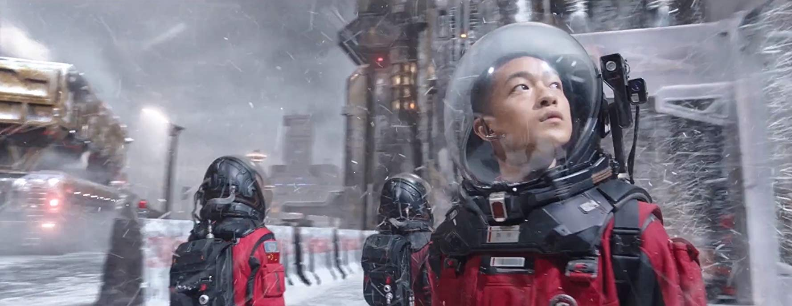

“Another world is possible,” says one popular protest slogan, but there is no guarantee it will be a better one. This course comprises an immersive survey of science fiction – the literary genre devoted to imagining the alterity of the future – as it takes on a unique and pressing relevance in modern and contemporary East Asian culture and society. If, as eminent literary critic Fredric Jameson proposes, science fiction stands as “realism for the 21st century,” how might this genre defamiliarize and reevaluate present global issues, including climate change, cyber-policing, reproductive justice, racism and colonialism, bioethics, and the military-industrial complex? How do these social problematics as well as the science fiction genre itself pertain to the East Asian experience, either as techno-Orientalist foil for canonical Western authors or as a rising regional force in the global technology market and culture industry? To respond to these and related questions, we will survey major and emerging SF authors from China, Japan, Taiwan, and Korea, coupling our readings with reflections on the genre’s limits and possibilities by leading Western SF writers. Providing students with both comprehensive training in literary analysis and critical thinking as well as a substantive sociohistorical introduction to contemporary East Asian societies and politics, the course will constitute a solid foundation for further study in East Asian humanities.

Course evaluation will include short bi-weekly discussion forum postings on assigned readings (40%); 2 longer reading response papers (min. 1500 words each) on a specific prompt pertaining to class materials and/or discussion to be assigned at least one week in advance of the due date (40%); an in-depth in-class presentation on an assigned reading of the student’s choice (5%); and evaluation of in-class participation during lectures and discussion sections (15%). All readings will be in English; no prior knowledge of Asian languages and/or cultures expected.

Course Policies
-During class time, attentive and active participation is expected
-All reading assignments are mandatory – students will be expected to
come to class having completed the readings
- Use of laptops, tablets, smartphones, mp3 players, or other electronic devices during
class time is discouraged (those with DSP accommodation may be excused from
this policy)
-Late assignment submissions will be considered on a case-by-case basis

Grading Breakdown
Participation: 15%
Forum Postings: 20%
Presentation: 5%
Response Essays (3 total): 60%

Recommended Readings:
Kim Stanley Robinson, “Dystopias Now ,” Commune Magazine, November 2nd, 2018.
Ursula K. LeGuin, "American SF and The Other," in The Language of the Night: Essays on Science Fiction (HarperPerennial, 1989), pp. 93-96.
Stephen Hong Sohn, “Alien/Asian: Imagining the Racialized Future,” in Science Fiction Criticism: An Anthology of Essential Writings, ed. Rob Latham, Bloomsbury (2017), pp. 503-516.
David S. Roh, Betsy Huang, and Greta A. Niu, "Technologizing Orientalism: An Introduction," in Techno-Orientalism: Imagining Asia in Speculative Fiction, History, and Media (Rutgers University Press, 2015), pp. 1-19.
Donna Haraway, “A Cyborg Manifesto : Science, Technology, and Socialist-Feminism in the Late Twentieth Century”
Xia Jia, “What Makes Chinese Science Fiction Chinese ?
Science Fiction in Korea: Between History, Genre, and Politics

Course Schedule

Week 1 – Science Fiction and East Asia
T 1/17 Course Introduction
Th 1/19 Park Min-gyu, “Road Kill,” trans. Esther Song, Azalea: Journal of Korean Literature & Culture, vol. 6, 2013, pp. 135-155.

Week 2 - Ice Age I
T 1/24 Abe Kōbō, Inter Ice Age 4 (Tuttle, 1974)
Th 1/26 Abe Kōbō, Inter Ice Age 4 (Tuttle, 1974)
Week 3 - Ice Age II
T 1/31 Abe Kōbō, Inter Ice Age 4 (Tuttle, 1974)
Th 2/2 Abe Kōbō, Inter Ice Age 4 (Tuttle, 1974)
Christopher Bolton, “Whirring Clicking Poetry: Inter Ice Age 4,” Sublime Voices: The Fictional Science and Science Fiction of Abe Kōbō (Harvard UP, 2009), pp. 76-129.

Week 4 – Membranes
T 2/7 Chi Ta-wei, The Membranes: A Novel (Columbia UP, 2021), pp. 1-89.
Th 2/9 Chi Ta-wei, The Membranes: A Novel (Columbia UP, 2021), pp. 90-136.
Ari Larissa Heinrich, “Promiscuous Literacy: Taipei Punk and the Queer Future of The Membranes,” pp. 137-155.

Week 5 – Electric Dreams
T 2/14 Egoyan Zheng, "The Dream Devourer" and Lo Yi-Chin, "Science Fiction: A Chapter of Daughter" in The Reincarnated Giant: An Anthology of Twenty-First Century Chinese Science Fiction (Columbia, 2018), pp. 111-129; 174-196.
Th 2/16 Bok Geo-il, "Along the Fragments of My Body," in Readymade Bodhisattva: The Kaya Anthology of South Korean Science Fiction, ed. by Sunyoung Park and Sang Joon Park (Kaya, 2019), pp. 111-129.

Week 6 – Cyborg Manifestoes
T 2/21 Kim Bo-young, "On the Origin of Species," in On the Origin of Species and Other Stories, ed. Sunyoung Park (Kaya, 2021), pp. 148-224.
Th 2/23 Kim Bo-young, "On the Origin of Species," pp. 242-297.
Recommended: Donna Haraway, “A Cyborg Manifesto : Science, Technology, and Socialist-Feminism in the Late Twentieth Century”

Week 7 – Dystopia
T 2/28 Izumi Suzuki, Terminal Boredom (Verso, 2021)
Th 3/2 Izumi Suzuki, Terminal Boredom (Verso, 2021)

Week 8 – Dysphoria
T 3/7 Yoko Tawada, The Emissary (New Directions, 2018)
Th 3/9 Yoko Tawada, The Emissary (New Directions, 2018)

Week 9 – Apocalypse
T 3/14 Choi Jin-young, To the Warm Horizon (Honford Star, 2021)
Th 3/16 Choi Jin-young, To the Warm Horizon (Honford Star, 2021)

Week 10 – Eco-Critique
T 3/21 *Response Paper 1 Due*
In-Class Film: Bong Joon-ho, Snowpiercer (S. Korea, 2013)
Th 3/23 Ch'oe Ryon, "Make the Ocean Blue," Azalea: Journal of Korean Literature and Culture, vol. 2 (2008), pp. 167-191.

*Spring Break*

Week 11 – Waste Tides
T 4/4 Chen Quifan, Waste Tide (Tor Books, 2020)
Th 4/6 Chen Quifan, Waste Tide (Tor Books, 2020)

Week 12 – Waste Tides
T 4/11 Chen Quifan, Waste Tide (Tor Books, 2020)
Th 4/13 Chen Quifan, Waste Tide (Tor Books, 2020)

Week 13 – Planetary Engineering
T 4/18 Cixin Liu, “The Wandering Earth” and “For the Benefit of Mankind,” in The Wandering Earth (TOR, 2022), pp. 1-49; 155-208.
Film: Frant Gwo, The Wandering Earth (China, 2019); Frant Gwo, The Wandering Earth II (2023)
Th 4/20 Hao Jingfang, "Folding Beijing” (2012)

Week 14 – Long Distance Love
T 4/25 Kim Bo-young, “I’m Waiting for You” and “On My Way to You,” in I’m Waiting for You and Other Stories (Harper Voyager, 2021), pp. 1-60; 215-282.
Th 4/27 Kim Cho-yŏp, "If We Cannot Travel at the Speed of Light," trans Eunsol Kim, Azalea: Journal of Korean Literature & Culture, vol. 15, 2022, pp. 327-350.

*Response Paper 2 Due Monday of Finals Week*

